Esraa Hassouna
IOT

Linux Lab5

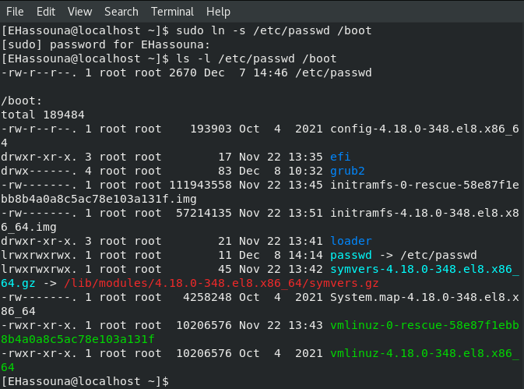
11. Create a symbolic link of /etc/passwd in /boot.

12. Create a hard link of /etc/passwd in /boot. Could you? Why?
